TG/81/3
Wheat/Koring, 2001-03-28

Reference Number/Verwysingsnommer
(for office use/vir kantoorgebruik)

TECHNICAL QUESTIONNAIRE
to be completed in connection with an application for a plant breeder’s right
and/or recognition of a variety

TEGNIESE VRAELYS
om saam met ‘n aansoek om planttelersregte en/of variëteitserkenning voltooi te word
1. Species/Spesie Triticum aestivum L.

WHEAT

KORING

- Applicant (Name and address of local company/organisation)
Aansoeker (Naam en addres van plaaslike firma/organisasie)

Tel.: ……………………………. Fax/Faks: ………………………….
Contact person/Kontakpersoon: …………………………………………… ……….
E-mail: ………………………………………………………………………………..
- Proposed denomination or breeder’s reference

Voorgestelde benaming of telersverwysing

4. Information on origin, maintenance and reproduction of the variety

Inligting oor oorsprong, instandhouding en voortplanting van die variëteit

4.1 Reproduction and maintenance/Voortplanting en instandhouding
i) Hybrid/Baster [ ]
ii) Open-pollinated variety/Oopbestuifde variëteit [ ]
iii) Inbred line/Ingeteelde lyn [ ]
iv) Other/Ander [ ]
  - Composition of variety (hybrids only) / Samestelling van variëteit (slegs basters)
……………………………………………………………………………………..
……………………………………………………………………………………..
……………………………………………………………………………………..
4.3 Origin/Oorsprong
i) Imported from/Ingevoer vanaf …………………………………………..
OR/OF
ii) Bred locally/Plaaslik geteel [ ]
  - Genetic manipulated organisms/Geneties gemanipuleerde organismes
- Was genetic manipulation used in the breeding program?/ Yes/Ja[ ]
Is genetiese manipulering betrokke? No/Nee[ ]
- Specify the organism from which the genetic material originated/
Spesifiseer die organisme waarvandaan die genetiese materiaal verkry is
…………………………………………………………………………………………..
…………………………………………………………………………………………..
…………………………………………………………………………………………..
4.5 Other information
Has this variety been sold or marketed in South Africa previously?
Is hierdie variëteit al voorheen in Suid-Afrika verkoop of bemark?
Yes/Ja [ ] No/Nee [ ]
If yes, indicate where and when/Indien ja, dui aan waar en wanneer:
………………………………………………………………….
………………………………………………………………….
- Characteristics of the variety to be indicated (the number in brackets refers to the corresponding characteristic in the Test Guidelines; please mark the state of expression which best corresponds)./
Kenmerke van die variëteit wat aangetoon moet word (die nommer in hakies verwys na die ooreenstemmende kenmerk in die UPOV-riglyne); merk asseblief in die toepaslike spasie by die ooreenstemmende kenmerk.

 | CHARACTERISTICS /  KENMERKE | NOTE/  NOTA
5.1 | Seasonal type | winter type/winter tipe | 1 [ ]
(33) | Seisoentipe | alternative type/alternatiewe tipe | 2 [ ]
 |  | spring type/lente tipe | 3 [ ]
5.2 | Time of ear emergence (first spikelet | ………………………………… | days/dae
(5) | visible on 50% of ears; quote number of
 | days after planting of variety as well as for | …………………………………
 | 2 well-known, comparable S.A. varieties) | …………………………………
 | Tyd van aaremersie (eerste aartakkie
 | sigbaar op 50% van are; gee gemiddelde | …………………………………
 | aantal dae van aaremersie na saai van variëteit, asook vir 2, vergelykbare | …………………………………
 | S.A. variëteite)
5.3 | Plant: height (stem & ear; quote height of | ………………………………… | Cm
(12) | variety as well as for 2 well-known, comparable S.A. varieties) | …………………………………
 | Plant: hoogte (halm en aar; gee hoogte van | …………………………………
 | Variëteit asook vir 2 bekende,
 | Vergelykbare S. A. variëtet) | …………………………………
 |  | …………………………………
5.4 | Straw: section (halfway between 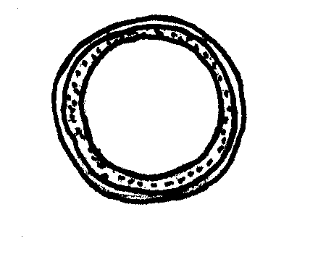 | pith thin/dun murg | 1 [ ]
(13) | base of ear and stem node below) 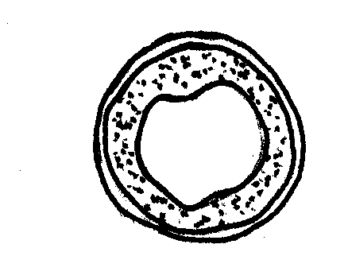 | pith medium/medium murg | 2 [ ]
 | Strooi: deursnit (tussen aarbasis 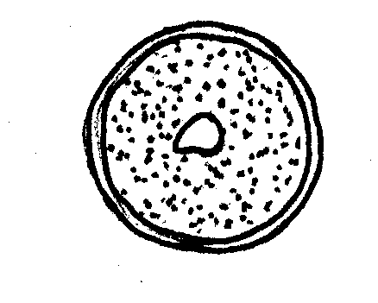 | pith thick/dik murg | 3 [ ]
 | en laaste knoop onder aar)
5.5 | Ear: colour (at maturity) | white/wit | 1 [ ]
(14) | Aar: kleur (wanneer ryp) | coloured/gekleurd | 2 [ ]
5.6 | Ear: shape 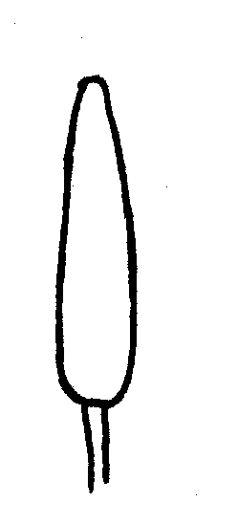 | tapering/piramiedvormig | 1 [ ]
(15) | Aar: vorm 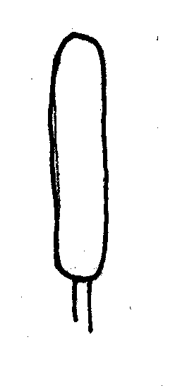 | Parallel | 2 [ ]
 | 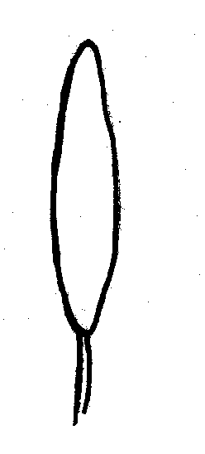 | fusiform/sigaarvormig | 3 [ ]
 | 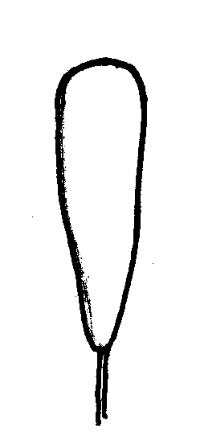 | clavate/kegelvormig | 4 [ ]
5.7 | Ear: density | lax/yl | 3 [ ]
(16) | Aar: digtheid | Medium | 5 [ ]
 |  | dense/dig | 7 [ ]
5.8 | Awns or scurs: presence 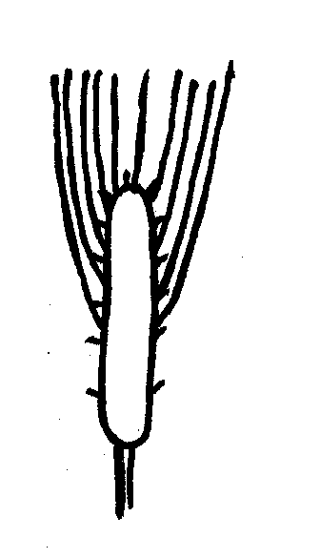 | both present/beide aanwesig | 1 [ ]
(17) | Kafnaalde of speldepunte: aanwesigheid  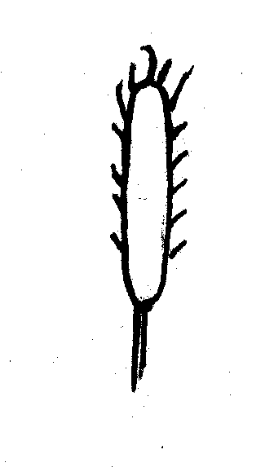 | scurs present/speldepunte aanwesig | 2 [ ]
 | 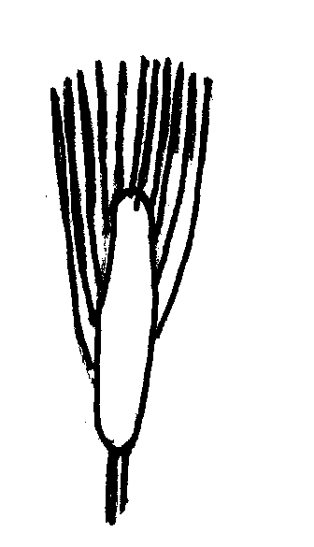 | awns present/kafnaalde aanwesig | 3 [ ]
5.9 | Grain: shape 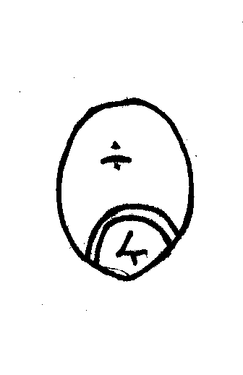 | rounded/gerond | 1 [ ]
(29) | Graan: vorm 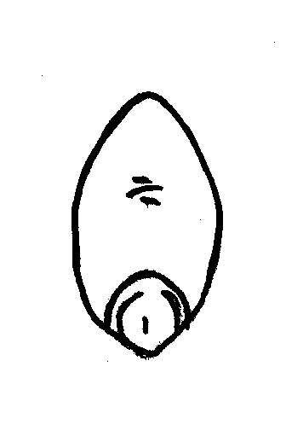 | ovoid/eiervormig | 2 [ ]
 | 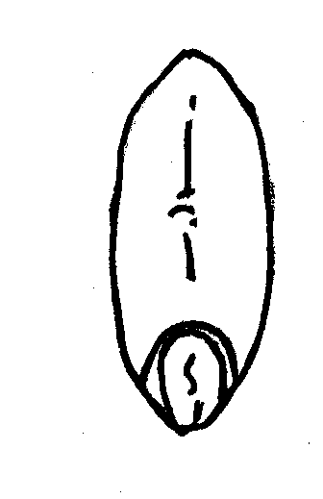 | elongated/verleng | 3 [ ]
5.10 | Grain: colour | white/wit | 1 [ ]
(30) | Graan: kleur | red/rooi | 2 [ ]
5.11 | Grain: brush hair length in dorsal view  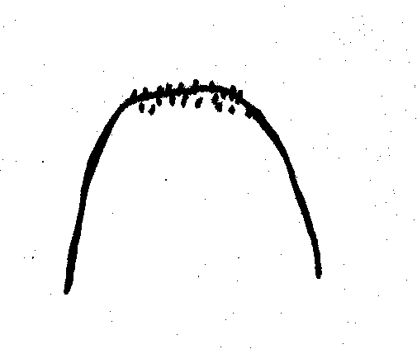 | short/kort | 3 [ ]
(31) | Graan: haarlengte op rugkant 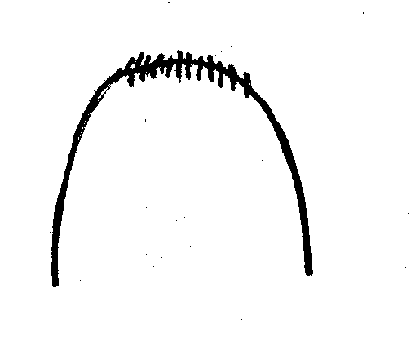 | medium | 5 [ ]
 | 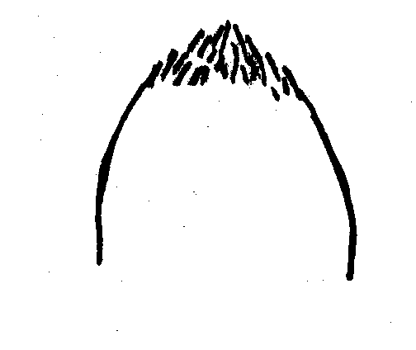 | long/lank | 7 [ ]
5.12 | Type of cultivation | dry land/droë land | 1 [ ]
 | Tipe verbouing | irrigation/besproeiïng | 2 [ ]

6. Similar varieties and differences from these varieties (varieties known in South Africa)

Soortgelyke variëteite en verskille van hierdie variëteite (variëteite bekend in Suid-Afrika)
Denomination of similar variety / Benaming van soortgelyke variëteit | Characteristic in which the similar variety is different* / Kenmerk waarin soortgelyke variëteit verskil*) | State of expression of similar variety / Uiting van kenmerk van soortgelyke variëteit | State of expression of candidate variety / Uiting van kenmerk van kandidaat variëteit
* In the case of identical states of expressions of both varieties, please indicate the size of the difference.
In geval van identiese uiting van kenmerke van beide variëteite, dui asb. die grootte van die verskil aan.

7. Additional information which may help to distinguish the variety/

Addisionele inligting wat kan help om die variëteit te onderskei
7.1 Resistance to pests and diseases/Weerstand teen siektes en plae
…………………………………………………………………………………………….
…………………………………………………………………………………………….
…………………………………………………………………………………………….
…………………………………………………………………………………………….
7.2 Special conditions for the examination of the variety

Spesiale toestande vir die ondersoek van die variëteit
……………………………………………………………………………………………
……………………………………………………………………………………………

7.3 Other information
……………………………………………………………………………………………
……………………………………………………………………………………………
……………………………………………………………………………………………

8. Authorization for release/Magtiging vir vrystelling
(a) Does the variety require prior authorization for the release under legislation concerning the protection of the environment, human and animal health?
Benodig die variëteit vooraf magtiging vir vrystelling onder wetgewing wat die omgewing, mens- en dieregesondheid beskerm?
Yes/Ja [ ] No/Nee [ ]
(b) Has such authorization been obtained?
Is sulke magtiging verkry?
Yes/Ja [ ] No/Nee [ ]
If the answer to that question is yes, please attach a copy of such an authorization.
Indien die antwoord ja is, heg asseblief ‘n afskrif van die magtiging aan.

Signature ……………………………………….. Date ………..…………………
Handtekening Datum

